**Online Shopping Project by Team 4**

**Team Members :**

1. Satya Garapati - Team leader
2. Himaja Takkellapati
3. Kinnera Kotaprolu
4. Mamatha Mallela
5. Lalitha Priya Satravada
6. Priyanshi Goel
7. Gaurav Suryawanshi

**Technology Used:**

❖ Asp.Net Core MVC

❖ Database - Sql

❖ EF Core- Database First Approach

**Modules:**

❖ Admin Module

❖ Retailer Module

❖ Customer Module

**Admin Module:**

**Features:**

❖ Login, SignUp and Forgot password Modules

❖ Crud Operation on Retailer - Edit/Delete

❖ Admin Dashboard – Admin Profile , List of Retailers , List of Products

**Retailer Module:**

**Features:**

❖ Login, SignUp and Forgot password Modules

❖ Crud Operation on Product Details-Add/Edit/Delete

❖ Search Operation on Category

❖ My Profile

**Customer Module:**

**Features:**

❖ Login, SignUp and Forgot password Modules

❖ Search Operation on Products

❖ Add To Cart

❖ Product Order Placement Module

❖ My Order View Module

❖ My Profile

**Database ER Diagram :**

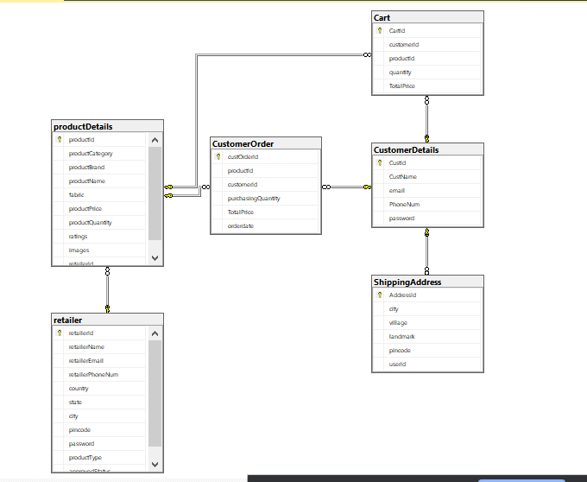

**Project Task Done By Teammates**

|  |  |
| --- | --- |
| **Name** | **Task** |
| Lalitha and Mamatha | ❖ Implementation On Admin Module  ❖ Login & signup Page  ❖ Forget Password Module |
| Satya and Kinnera | ❖ DB Design and logic Implementations  ❖ Implementation Of Homepage Layout With Product Display & Search Products.  ❖ Crud Operation Product Module  ❖ Crud Operation On Category Module |
| Himaja and Priyanshi | ❖ Add To Cart Module  ❖ Product Order Placement Module  ❖ My Order View Module |
| Gaurav | ❖ Implementation Of ProductImage Upload Module  ❖ Implementation Of customer module  ❖ Implementation Of Retailer Module |